**Word Card**

**How to choose the words**

When you read a text, you don’t know some of the words yet.

These are new words.

To understand the text, you don’t have to know *all* the words.

You only choose the important new words.

* Read your text.
* Underline the new words.
* Choose 5 to 10 important words.

**How to learn new words**

You learn a word if you *do* many things with it.

Below you can find things that you can do to learn words.

Not all things work for everybody.

Try them and find out what works for you.

1. **Make a word list**



* Use a journal, a computer or a tablet.
* Add information to the word:

|  |  |
| --- | --- |
| **the word** | respect |
| **meaning** | to be polite and to show honour to an important person or thing. |
| **a sentence with the word** | I respect my grandfather. |
| **a word that means the same** | esteem |
| **the opposite ↔** | disrespect |
| **a picture** |  |

1. **Make a word web**

What comes into your head when you think of this word??

1. **Play a word game**

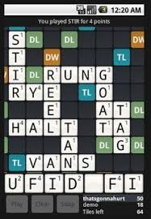

* Do you know words with a similar **meaning**?

|  |  |
| --- | --- |
| Respect: | friendly, polite, kind, correct. |

* Do you know words that that go with the new word?

|  |  |
| --- | --- |
| Respect: | to treat someone with respect,  to show respect for other people friendly |

* Do you know words that

1. **Listen and observe**



* Do you **hear** the word on the television or on the radio?
* Do you **hear** the word being used around you?
* Do you **see** the word somewhere around you?

For example on a billboard, in a newspaper, or a leaflet.

**And now exercise!**

* **Read** the words again and again.
* **Write** down the words ten times.
* **Make** sentences with the word.
* Find **pictures** that go with the words.
* Use the words when you **talk**.