Reading Card

Which side?
Does your text look like this one? Does your text resemble this one?
Please read below. Please turn this card around
to continue reading.

Ellen is 34 years old.
She lives in a flat in London.
She has a six year old son and a nine year old daughter.
Ellen works in a nursery five days a week.
She makes £ 800 , -. Including social benefits she has about £ 1000 ,- to spend every month.

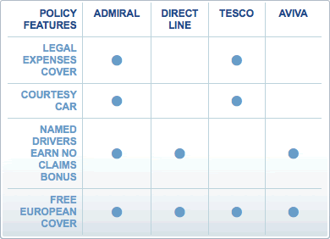

Reading texts

- Look at the text without reading it.
What do you already know about this text?
For example: is it a newspaper article, a leaflet, a work instruction?
Are there any pictures?
Read the title.
What do you think this text is about?
What do you already know about this subject?

- Read the text.
It is ok if you don’t understand everything yet.
Underline the words that you don’t know.

- Difficult words?  Read the text again.  Is the difficult word a long word?  Divide it into small parts.  You may understand it now.  Is it an new word?  Read the sentence following the word.  The meaning of the word is often explained.  Is it still not clear?  Use a dictionary.  Or ask someone for help. | For example: Uncertain  Un = not  Certain = sure  Uncertain = not sure  For example;  Tomatoes grow in a greenhouse.  A greenhouse is a building made of glass, used for growing plants that need warmth.

- Read the text once more.
Tell in your own words what you have just read.
Finding information

Sometimes, you don’t have to read the complete text.
You only want to find information, for example in:
- A class schedule
- A timetable for the bus

- Look at the text.
You don’t have to read all the words .
You don’t have to understand every word.

- Does the text have a title?
What kind of information can you find in this text?
What do you already know about this subject?

- What do you want to know?
Look up the information you want to know in the text.

Tip:
- A list of names is often alphabetical.
- A schedule often follows the days of the week or the months of the year.

